FINAL REPORT
Technova Software Hackathon – 2026

Project Title : Co-working Space Booking & Desk Management Platform
Team Name : VisionX
Team Lead : Hema Varshini K (7376252IT180)
Team Member: Rakshana R (7376252IT295)

Introduction
Co-working spaces have become increasingly popular among freelancers, startups, students, and remote employees. Managing workspace reservations manually often leads to scheduling conflicts, inefficient resource utilization, and poor user experience. A digital booking platform provides users with an easy way to reserve workspaces while helping administrators efficiently manage available resources.
Problem Statement
Many co-working spaces still depend on manual reservation systems or outdated booking processes. Users experience difficulty in checking workspace availability, booking suitable workspaces, and managing reservations. Administrators also face challenges in monitoring occupancy and avoiding booking conflicts.

Proposed Solution
The proposed web application enables
Users can:
- Search available workspaces
- View workspace details
- Book desks, cabins, and meeting rooms
- Manage reservations
- Cancel bookings
The administrator can:
- Manage workspaces
- Manage users
- Manage bookings
- Monitor occupancy
- Update workspace availability

Objectives
The objectives of the project are:
- Develop an online booking platform.
- Reduce manual booking processes.
- Prevent double booking.
- Improve workspace utilization.
- Provide responsive user experience.
- Simplify workspace management.

System Analysis
Existing System | Proposed System
Manual booking | Online booking
Phone reservations | Live availability
Paper registers | Booking history
Booking conflicts | Admin dashboard
No real-time availability | Responsive interface

System Design & Implemenation
Technologies Used
The project was developed using modern technologies that support responsive design, efficient data handling, and scalable application development.
Frontend Technologies
- HTML5 for structuring web pages.
- CSS3 for designing responsive and visually appealing user interfaces.
- JavaScript for implementing client-side functionality.
- React.js for building reusable UI components and improving user interaction.
Backend Technology
- Node.js was used to develop server-side functionality and manage communication between the frontend and database.
Database
- MongoDB stores user accounts, workspace details, booking information, and occupancy records.
UI/UX Design
- Figma was used to create wireframes, user interface designs, and interactive prototypes before implementation.
Development Tools
- Visual Studio Code for application development.
- Git and GitHub for version control and collaborative development.
- Postman for testing backend APIs.
Deployment
- Vercel for frontend deployment.
- Render for backend deployment.
- MongoDB Atlas for cloud database hosting.
Project Modules
The application consists of several independent modules that work together to provide complete workspace booking functionality.
1. User Authentication Module
- User registration
- User login
- Secure authentication
- User profile management
- Logout functionality
2 . Workspace Management Module
- Display available workspaces
- Search functionality
- Filter workspaces
- Workspace details
3. Booking Module
- Select workspace
- Choose booking date
- Select time slot
- Verify availability
- Booking confirmation
- Booking cancellation
4. Booking Management Module
- View booking history
- Track booking status
- Cancel reservations
- Manage upcoming bookings
5. Admin Module
- Admin login
- Dashboard
- Manage users
- Add workspaces
- Edit workspaces
- Delete workspaces
- Manage bookings
- Update availability
6. Occupancy Monitoring Module
- Monitor occupancy
- Track available workspaces
- Display booking statistics
Frontend Implementation
The frontend of the application was developed using React.js along with HTML5, CSS3, and JavaScript. The interface was designed to provide a responsive and user-friendly experience across desktop, tablet, and mobile devices.
Major frontend pages include:
- Home Page
- User Login
- User Registration
- Workspace Listing
- Workspace Details
- Booking Page
- Booking History
- User Profile
- Admin Login
- Admin Dashboard
Reusable React components were developed to improve maintainability and reduce code duplication.
Backend Implementation
The backend was developed using Node.js to manage application logic and communication between the frontend and database.
The backend performs the following operations:
- User authentication
- Workspace management
- Booking processing
- Booking validation
- Occupancy tracking
- Administrative operations
RESTful APIs were created to exchange data between the frontend and backend efficiently.
Database Implementation
MongoDB was used as the primary database for storing application data.
The database maintains information related to:
- User Accounts
- Administrator Accounts
- Workspace Details
- Booking Records
- Workspace Availability
- Occupancy Status
The database structure was designed to support efficient retrieval and modification of booking information while minimizing redundancy.

Github links :
Repository link: https://github.com/vhema8472/VisionX.git
website link

Summary
The implementation phase successfully transformed the system design into a fully functional web application. The modular architecture improved scalability, maintainability, and code organization. The integration of React.js, Node.js, and MongoDB enabled efficient workspace management, reliable booking operations, and an intuitive user experience. The implemented system satisfies the project requirements by providing a centralized platform for workspace booking while offering administrators comprehensive management capabilities.

Proof:
Figma:
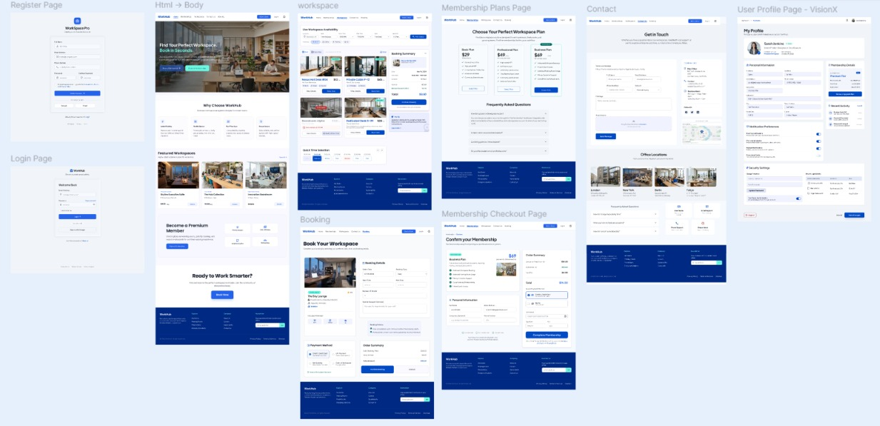

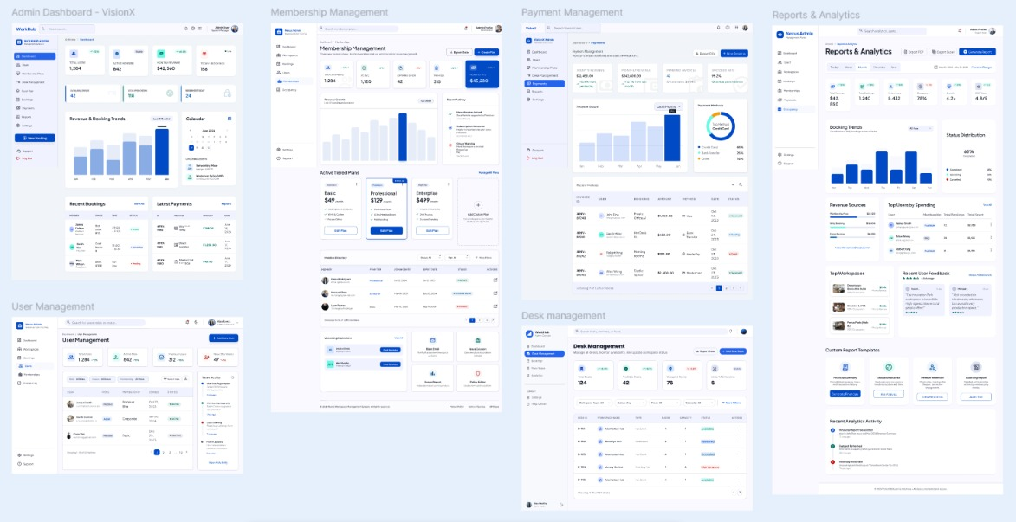

Frontend
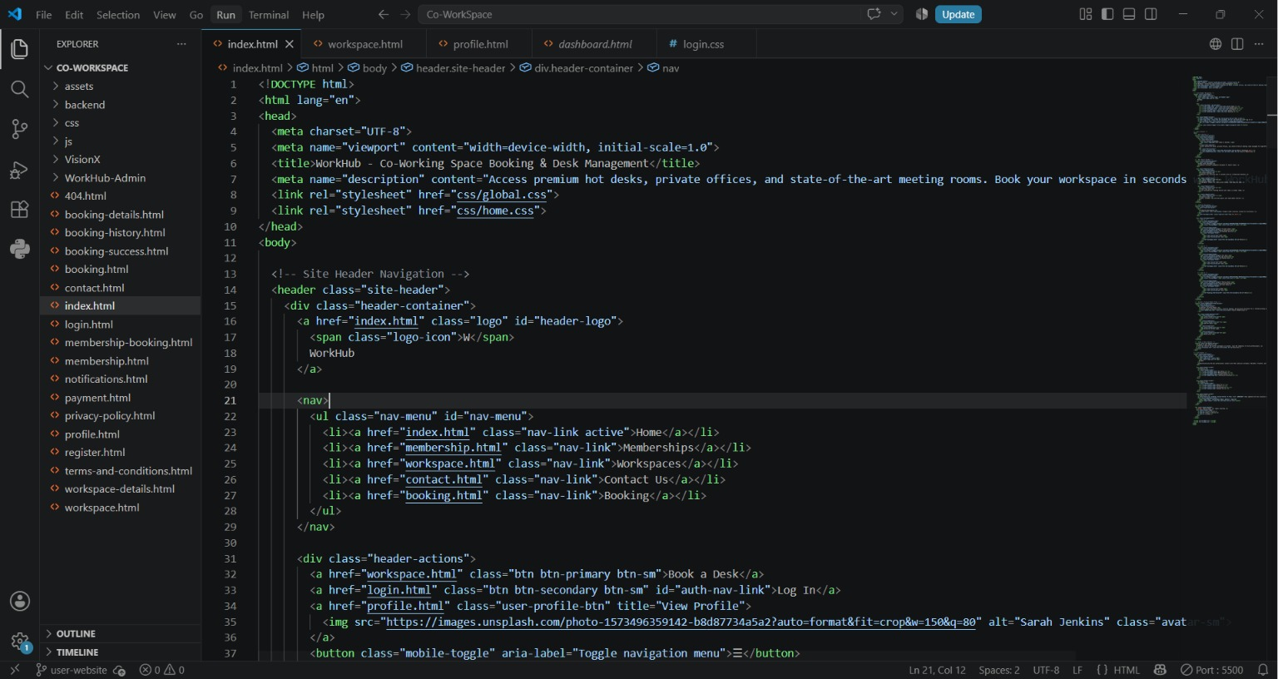

User Dashboard:
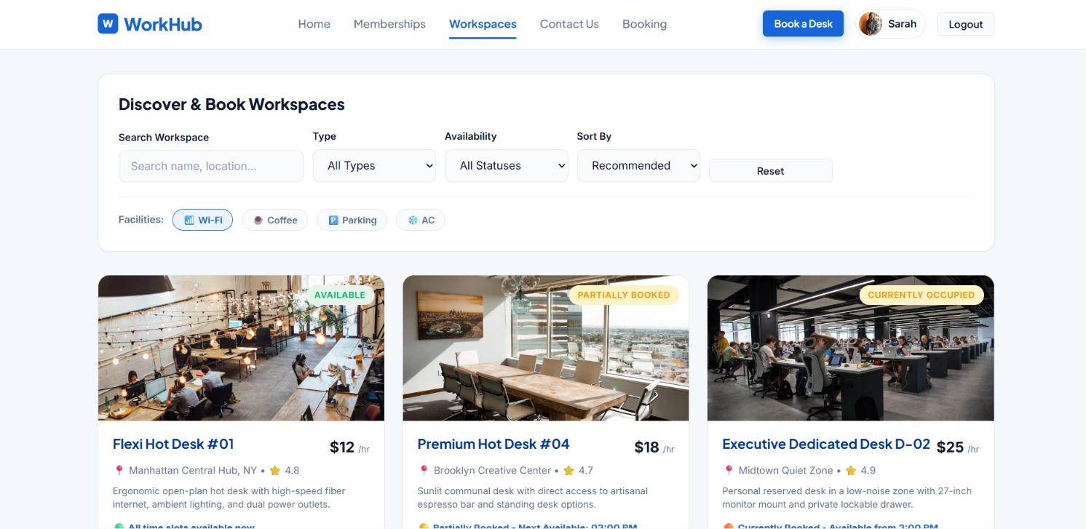

Admin Dashboard:
